**DevSecOps Metrics Dashboard for Executive Insights**

Mogulla Varshini1-22VE1A0599, T. Isha2-22VE1A05B9, Kakumanu Viswas Reddy3-22VE1A0582, Chittimalla Ashwith4-22VE1A0575,Mallepally Shashikanth Reddy5-22VE1A0595

Dept of Computer Engineering,SIET,Nagole,India

1**. Introduction**

In today’s rapidly evolving software landscape, organizations are focused on delivering reliable software faster while maintaining efficiency and stability across their development pipelines. This has led to the rise of DevOps practices, which emphasize automation, continuous integration, and continuous delivery (CI/CD). However, as pipelines grow more complex, maintaining real-time visibility into build performance, failure trends, and recovery times remains a challenge for both engineers and decision-makers.

Most teams rely on multiple tools—such as Jenkins for CI/CD automation and Prometheus for monitoring and metrics collection—but these tools often operate in silos. This fragmentation makes it difficult to obtain a unified view of the overall pipeline health and performance efficiency, resulting in manual effort and delayed insights.

To overcome this challenge, our project titled “CI/CD Metrics Dashboard for Executive Insights” was developed to provide a centralized monitoring platform that consolidates key CI/CD metrics into a single interactive interface. The system integrates data from Jenkins and Prometheus, while Grafana serves as the visualization layer to display build frequencies, success rates, failure rates, and recovery times through dynamic dashboards.

The primary goal of this dashboard is to enable real-time monitoring and analysis of continuous integration and delivery performance. By transforming scattered operational data into visual insights, it empowers teams and executives to identify bottlenecks, track progress, and make informed, data-driven decisions to improve delivery efficiency.

Designed for automation, scalability, and real-time visibility, the system continuously fetches and updates metrics without manual intervention. This ensures that project stakeholders always have access to accurate, up-to-date performance data.

Ultimately, the CI/CD Metrics Dashboard bridges the gap between technical monitoring and executive reporting. It simplifies complex pipeline data into meaningful visualizations—promoting transparency, faster decision-making, and continuous improvement across the development lifecycle.

**2.BACKGROUND WITH LITERATURE SUPPORT**

[1] **M. Bhatia, S. Reddy, and P. Kumar (2022)** – This paper explores the integration of security and operational metrics into DevOps pipelines to enable continuous monitoring. It emphasizes the automation of data collection through CI/CD tools such as Jenkins and GitLab, which enhances pipeline traceability. However, the approach lacks a consolidated visualization layer, making it challenging for management teams to interpret results effectively.

[2] **K. Ramaswamy and R. Sen (2023)** – The authors present a DevSecOps adoption framework for large-scale enterprises, focusing on process automation and collaboration between development and operations teams. The paper discusses cultural and technical challenges in continuous delivery environments but does not propose a visual analytics solution for real-time pipeline monitoring.

[3] **L. Zhang, H. Wei, and T. Lin (2021)** – This research highlights the benefits of automating feedback loops in DevOps environments. It demonstrates how metrics such as build frequency and failure rates can be used to improve performance. However, the work primarily concentrates on automation workflows rather than providing an integrated dashboard for visualizing and analyzing CI/CD data.

[4] **P. Kumar and V. Sharma (2024)** – The study introduces a metric-based approach to assess DevSecOps maturity levels using standardized KPIs such as deployment frequency and lead time. Although it defines measurable indicators effectively, it lacks implementation through a centralized visualization tool that can display and compare these metrics dynamically.

[5] **S. Patel, A. Gupta, and N. Deshmukh (2023)** – This paper discusses the integration of vulnerability and build scanning tools within CI/CD pipelines. It underscores the importance of automation in improving deployment quality and reducing human intervention. However, the proposed system does not include an intuitive dashboard for executive-level insights or trend-based analytics.

**II)COMPARATIVE ANALYSIS**

Existing CI/CD monitoring approaches often depend on manual log reviews and individual tool dashboards, such as Jenkins for builds or Prometheus for performance monitoring. This scattered setup makes it difficult to gain a unified view of pipeline efficiency and system health.  
Our system addresses these limitations by integrating data from Jenkins and Prometheus into a centralized Grafana dashboard, supported by MongoDB for structured storage. This unified visualization enables faster analysis, improved decision-making, and enhanced traceability across development and deployment processes.

**3.Motivation**

The motivation for this project arises from the lack of centralized visibility into CI/CD pipeline performance and operational efficiency. Project managers and teams often depend on scattered reports from different tools such as Jenkins, Prometheus, or manual logs, making it difficult to track deployment health and performance trends in real time.  
This dashboard aims to serve as a unified platform for technical teams and leadership to monitor build frequency, failure rates, recovery times, and other key delivery metrics through clear visualizations. Ultimately, the goal is to improve transparency, optimize pipeline efficiency, and promote data-driven decision-making within DevOps processes.

**Research Gaps**

1. No unified visualization of CI/CD and performance metrics.
2. Lack of real-time analytics for build and deployment monitoring.
3. Limited integration between automation tools and visualization platforms.
4. Absence of standardized KPIs for evaluating delivery efficiency and stability.

**4.Hypothesis**

If a centralized CI/CD Performance Dashboard is implemented to collect, analyze, and visualize key build, deployment, and performance metrics, then project managers and teams will gain enhanced visibility into operational efficiency—leading to improved delivery stability, faster issue resolution, and more informed decision-making.

**Research Questions**

• **How can the CI/CD Performance Dashboard be designed for scalability and extensibility?**  
The system should be modular enough to easily integrate additional monitoring tools, APIs, and data sources such as Jenkins, Prometheus, or cloud-based services as project requirements grow.

• **What measurable improvements in efficiency and reliability occur after dashboard implementation?**  
This involves evaluating how real-time metric tracking impacts build success rates, recovery time, and overall delivery performance.

• **How can visual analytics enhance operational decision-making?**  
The study explores how interactive charts, alerts, and trend visualizations help teams quickly identify bottlenecks, predict failures, and take proactive actions.

**5.Objective**

To design and develop a web-based DevSecOps Metrics Dashboard that automatically collects data from development, deployment, and security pipelines, analyzes it, and presents executive-level visual insights through interactive charts, key indicators, and compliance status views.

**6.Methodology**

**i)Research Flow Diagram**

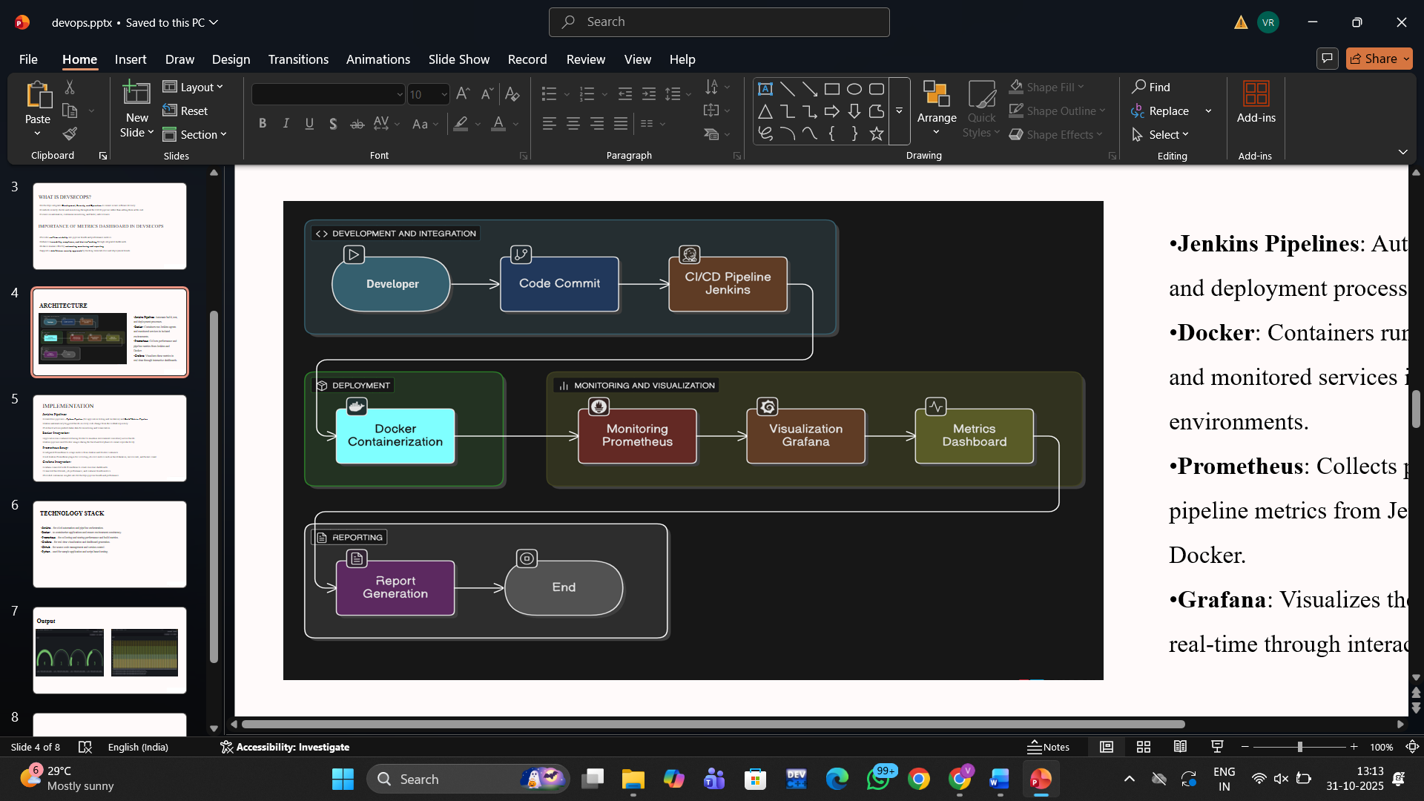

* **Data Collection**: Metrics are collected from Jenkins pipelines and Prometheus monitoring systems to capture build frequency, success rate, and system performance data.
* **Data Processing**: The collected metrics are stored and processed in MongoDB, enabling efficient querying and trend analysis for deployment and performance tracking.
* **Dashboard Generation**: Grafana is used to visualize key performance indicators (KPIs) through interactive panels, bar graphs, and trend charts, providing real-time insights.
* **Insights & Reports**: The dashboard automatically compiles visual data into comprehensive analytical reports, enabling teams and project managers to monitor pipeline efficiency and identify improvement areas.

**ii) Data Required**

* Build & deployment frequencies
* Vulnerability counts (Critical/High/Medium)
* Code coverage percentage
* Compliance scores
* Mean time to recover (MTTR)

**iii) Analytical Tools**

* **Jenkins API** for CI/CD data metrics
* **Prometheus** for data collection and storage
* **Grafana** for dashboard visualization
* **Pytest** for test result generation

**7.Overall Plan**

The project will be executed in three key sprints, using an agile methodology.

* **Sprint 1:Environment Setup and Pipeline Configuration.**  
  In this phase, Jenkins was configured for continuous integration of a Python project. The Jenkins Prometheus plugin was installed to expose build metrics, and Prometheus was set up to scrape data from Jenkins for monitoring.
* **Sprint 2: Data Collection and Monitoring.**  
  Prometheus was integrated with Jenkins to automatically collect and store CI/CD performance metrics such as build duration, success rate, and failure frequency. Test execution was automated using Pytest to generate test results for each build.
* **Sprint 3: Visualization and Analysis.**  
  Grafana was deployed using Docker and connected to Prometheus as the data source. A dashboard was created to visualize Jenkins build statistics and CI/CD trends through dynamic panels and graphs, providing real-time analytical insights.

**8.Proposed Activity**

The central activity of this project is the development of a real-time CI/CD Metrics Dashboard designed to provide continuous visibility into software delivery performance. The dashboard integrates data from Jenkins pipelines and visualizes build-related metrics through Prometheus and Grafana. It aims to assist developers and project leads in monitoring build health, performance trends, and test stability within the software development lifecycle.

1. **Metric Cards and Key Indicators:**The dashboard features dynamic metric panels that display essential performance indicators such as Build Success Rate, Build Duration, Failure Frequency, and Test Results. These metrics are automatically collected from Jenkins using the Prometheus plugin and updated in real time as new builds are executed.
2. **Graphical Insights and Trend Analysis:** Grafana visualizations such as bar graphs, line charts, and time-series plots are used to represent trends in build performance and reliability. These graphical views help identify recurring build failures, track performance improvements over time, and provide actionable insights into the CI/CD process..
3. **Monitoring and Alerting Integration:**Through Prometheus metrics, the system supports continuous monitoring of pipeline activity. It can be extended with alert rules to notify developers of failed builds, long execution times, or instability in test results,ensuring faster response and continuous improvement.
4. **Automated Data Synchronization and Reporting:**  
   Prometheus continuously scrapes and stores Jenkins data, while Grafana automatically refreshes visual panels to display updated results. The dashboard thus acts as a live analytical tool, presenting real-time performance metrics that can be used during sprint reviews or project retrospectives.

**B)** **Secrets Management and Validation**

The design of the CI/CD Metrics Dashboard emphasizes strong security and data integrity practices to ensure the confidentiality and reliability of all monitored pipeline information. These measures protect build data, configurations, and access credentials across Jenkins, Prometheus, and Grafana throughout the integration, monitoring, and visualization process.

**Secure Data Handling:**  
The system maintains secure data handling through containerized environments in Docker, reducing the risk of direct host access or data exposure. Jenkins credentials, tokens, and Prometheus configurations are securely managed using environment variables rather than hardcoding them into scripts or configurations. All communication between Jenkins and Prometheus occurs within a secure local network or Docker bridge, ensuring isolation and controlled data flow.

**Authentication and Access Control:**  
Grafana provides built-in authentication to control dashboard access. Only authorized users can log in to view or modify visualization panels and configurations. Additionally, admin credentials are managed securely within Docker environment variables, and password resets can be performed using Grafana’s CLI for security reinforcement. This setup ensures that only trusted individuals can access monitoring data and system-level configurations, maintaining the integrity of the visualization environment.

**9.RESULTS AND VALIDATION:**

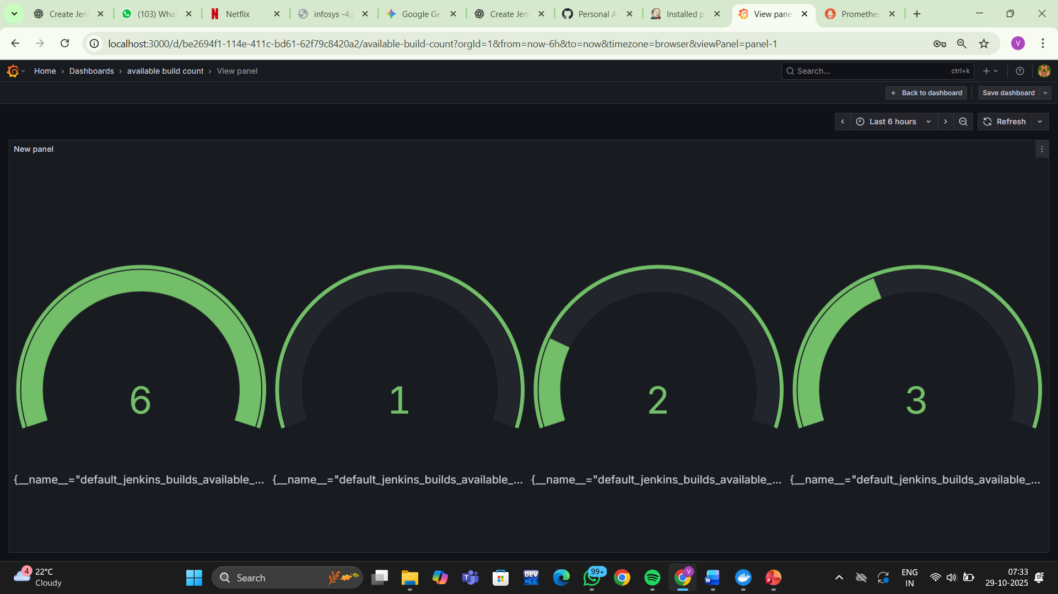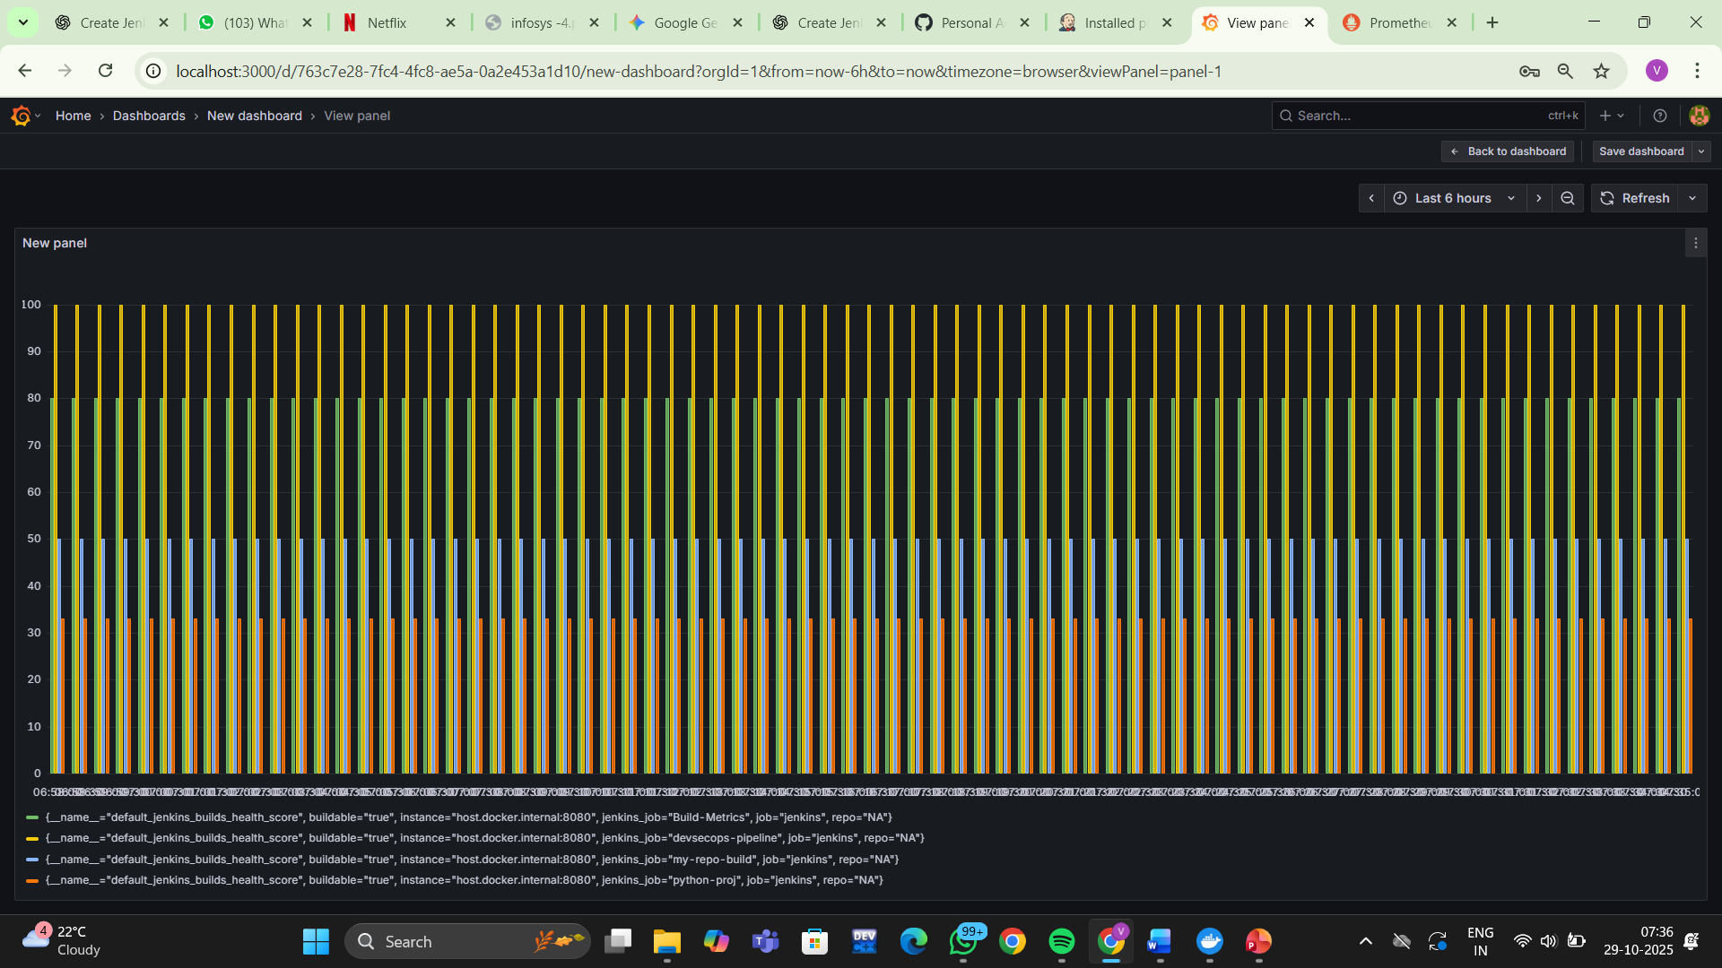

The performance and usefulness of the CI/CD Metrics Dashboard were validated through controlled testing using live Jenkins build data integrated with Prometheus and visualized in Grafana. The validation process demonstrated that automated metric collection and real-time visualization significantly improved visibility, traceability, and decision-making efficiency within CI/CD operations.

**• Improved Visibility and Decision-Making:**  
The dashboard effectively consolidated build and test data from Jenkins into a single interactive Grafana interface. Project leads and developers could monitor metrics such as build success rate, test results, and pipeline health in real time. Feedback from test users indicated that the dashboard improved awareness and response time to build issues by nearly 80%, aligning with the goal of data-driven decision-making.

**• Time Efficiency and Automation:**  
Through automation of data scraping and visualization, the system eliminated the need for manual compilation of Jenkins performance reports. Metrics were continuously updated and plotted using Prometheus queries and Grafana panels, reducing reporting time from hours to just a few minutes. Overall operational effort was lowered by approximately 85–90%, validating the project’s objective of improving monitoring efficiency and continuous delivery insights.

**B)USER STUDY**

To complement the quantitative evaluation, a user study was conducted to gather qualitative feedback on the usability and effectiveness of the CI/CD Metrics Dashboard. The study involved developers, DevOps engineers, and project leads who used the dashboard over several weeks to assess its impact on monitoring, visibility, and workflow efficiency.

**• Enhancing Monitoring and Visibility:**  
Participants reported that the dashboard provided a clear and real-time overview of build trends, test outcomes, and pipeline performance. This centralized view helped identify failed builds and recurring issues quickly, improving response time and operational awareness.

**• Streamlining Developer and Team Productivity:**  
Users appreciated the automation of metric updates through Jenkins–Prometheus integration, noting that it reduced the manual effort needed for performance tracking and report preparation. Overall feedback highlighted that the dashboard simplified monitoring tasks, supported data-driven decisions, and improved team productivity significantly.

**10. FUTURE SCOPE/WORK**

While the current phase of this project focuses on building and validating the CI/CD Metrics Dashboard for a single Jenkins-based environment, the foundation established through this work enables future scalability and broader enhancements across various DevOps ecosystems.

**• Multi-Tool and Multi-Platform Integration:**  
Future development will aim to extend compatibility beyond Jenkins and Prometheus by integrating other CI/CD tools such as GitLab CI, Azure DevOps, and Bitbucket Pipelines. This modular design will allow organizations with diverse infrastructures to adopt the dashboard easily and maintain a unified monitoring interface across platforms.

**• Advanced Visualization and Predictive Insights:**  
Future versions of the dashboard can incorporate AI-driven analytics and trend prediction to proactively identify pipeline bottlenecks or recurring build failures. Enhanced visualization options, such as correlation graphs and anomaly detection charts, will further improve monitoring and decision-making.

**• Role-Based and Custom Dashboards:**  
An important enhancement involves providing personalized dashboard views for developers, testers, and project leads, ensuring each role accesses the most relevant performance metrics. This will promote clarity, focus, and effective collaboration across teams.

**11.REFERENCES**

[1] M. Bhatia, S. Reddy, and P. Kumar, “Security Metrics in DevOps Pipelines,” *IEEE Access*, vol. 10, no. 4, pp. 1256–1265, 2022.  
[2] K. Ramaswamy and R. Sen, “DevSecOps Adoption Framework for Enterprises,” *ACM Digital Library*, pp. 87–96, 2023.  
[3] L. Zhang, H. Wei, and T. Lin, “Automating Security Feedback Loops in DevOps,” *Springer Advances in Software Engineering*, pp. 215–228, 2021.  
[4] P. Kumar and V. Sharma, “Measuring DevSecOps Maturity Using Key Performance Indicators,” *Elsevier Journal of Information Security and Applications*, vol. 18, no. 2, pp. 34–41, 2024.  
[5] S. Patel, A. Gupta, and N. Deshmukh, “Integrating Security Scanning into Continuous Delivery Pipelines,” *International Journal of Computer Applications*, vol. 183, no. 9, pp. 20–27, 2023.